Top of Form

Question 1: Skipped

What is the main benefit of Workplace Analytics?

* ​

It helps the organization to understand how groups collaborate.

**(Correct)**

* ​

It reduces costs by only charging for storage that you really need.

* ​

It reducing the time required to write reports in Word.

**Explanation**

Workplace Analytics helps you ***understand how your organization invests its time by giving you insight into how groups collaborate across the organization.***

Reference:

**https://docs.microsoft.com/en-us/learn/modules/harness-business-intelligence-with-microsoft-365-analytics-reporting/2-workplace-analytics**

Bottom of Form

Top of Form

Question 2: Skipped

Which Microsoft 365 for business subscription includes Azure Information Protection?

* ​

Microsoft 365 Business Basic

* ​

Microsoft 365 Business Premium

**(Correct)**

* ​

Microsoft 365 Business Standard

**Explanation**

***Microsoft 365 Business Premium***includes Azure Information Protection

Reference:

**https://docs.microsoft.com/en-us/learn/modules/identify-licensing-options-available-microsoft-365/2-compare-home-enterprise-business**

Bottom of Form

Top of Form

Question 3: Skipped

How can your organization receive on-site support from Microsoft?

* ​

Through community-based support.

* ​

Through Support Assistant

* ​

Through Premier Support

**(Correct)**

**Explanation**

***To get on-site support from Microsoft, your organization should use Premier Support.***

The Support Assistant is online bot. Community support is great for getting solutions from the experience of other users

Reference:

**https://docs.microsoft.com/en-us/learn/modules/describe-support-offerings-for-microsoft-365-services/2-explore-support-options**

Bottom of Form

Top of Form

Question 4: Skipped

Who is responsible for submitting a claim for Service Credit?

* ​

The Cloud Service Provider

* ​

Your organization

**(Correct)**

* ​

Microsoft

**Explanation**

Your organization should submit a claim with Microsoft. Microsoft is responsible for reviewing your organization’s claim.

Reference:

**https://docs.microsoft.com/en-us/learn/modules/describe-support-offerings-for-microsoft-365-services/3-explain-service-level-agreements**

Bottom of Form

Top of Form

Question 5: Skipped

What three phases does a feature have in the Microsoft 365 Roadmap?

* ​

In development, Launched, Retired

* ​

In development, Rolling out, Launched

**(Correct)**

* ​

In development, In testing, Launched

**Explanation**

The three phases that a feature has in the Microsoft 365 Roadmap are In development, Rolling out, and Launched

So that you can plan for the future, Microsoft regularly updates roadmaps for its products. Roadmaps include the status of a feature, whether it is in development, rolling out, or has launched, and the expected release date of that feature.

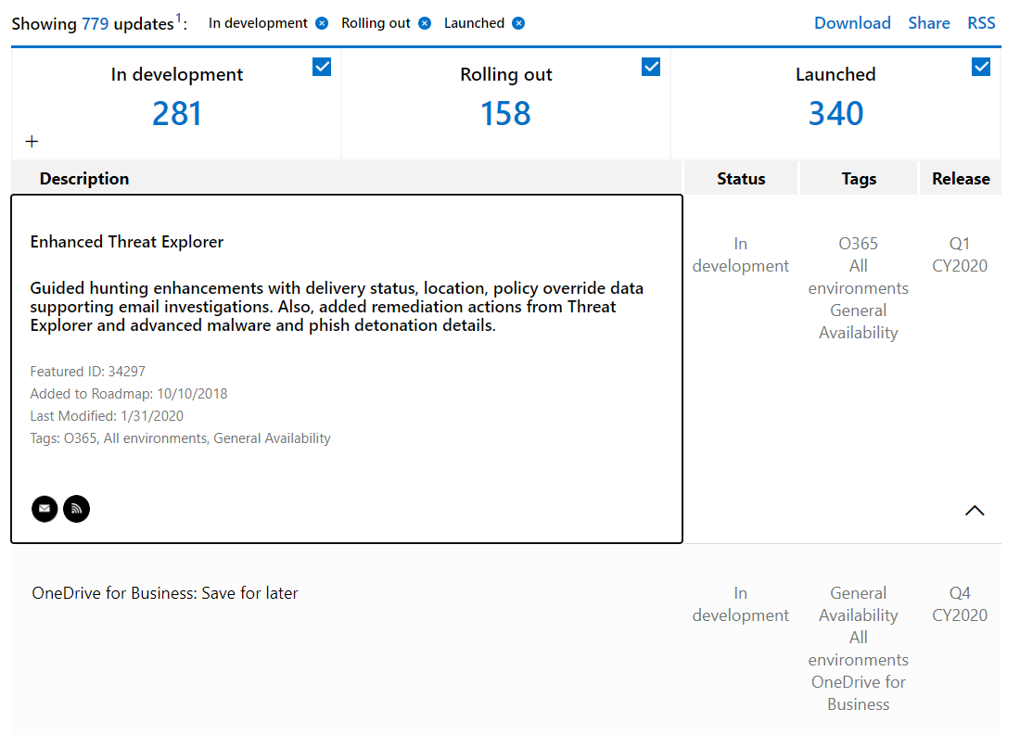

Reference:

**https://docs.microsoft.com/en-us/learn/modules/describe-service-life-cycle-microsoft-365/4-roadmap-portal**

Bottom of Form

Top of Form

Question 6: Skipped

What does Microsoft’s Discover & Respond solution do?

* ​

Protects against malware.

* ​

Helps you find, refine, and prepare relevant content.

**(Correct)**

* ​

Encrypts cloud data.

**Explanation**

Microsoft's Discover & Respond is ***designed to help you find relevant content, refine content, and prepare content to be handed off to the requesting body in an efficient way.***

Microsoft’s Discover & Respond solution is neither designed to protect an organization against malware nor designed to encrypt cloud data.

Reference:

**https://docs.microsoft.com/en-us/learn/modules/describe-microsoft-365-foundational-principles-solution-areas/3-review-microsoft**

Bottom of Form

Top of Form

Question 7: Skipped

Where can a user go, in order to manage their verification methods?

* ​

MyVerifications

* ​

MyAccessMethod

* ​

MyProfile

**(Correct)**

**Explanation**

You can use the ***myprofile.microsoft.com site to keep your verification methods and security information up to date.***

MyAccessMethod is not a valid site for keeping your verification methods and security information up to date.

Reference:

**https://docs.microsoft.com/en-us/learn/modules/describe-identity-access-management-capabilities-of-microsoft-365/4-multi-factor-authentication**

Bottom of Form

Top of Form

Question 8: Skipped

Which of the following is a Cloud Access Security Broker that supports various deployment modes including log collection, API connectors, and reverse proxy?

* ​

Microsoft Defender for Office 365 (MSDO)

* ​

Microsoft Defender for Identity (MSDI)

* ​

Microsoft Cloud App Security

**(Correct)**

**Explanation**

***Microsoft Cloud App Security***is a Cloud Access Security Broker that supports various deployment modes including log collection, API connectors, and reverse proxy.

***Microsoft Defender for Office 365 (MSDO)*** is a cloud-based email filtering service that helps protect your organization against unknown malware and viruses.

***Microsoft Defender for Identity (MSDI)***is a cloud-based security solution that identifies, detects, and helps you investigate advanced threats, compromised identities, and malicious insider actions directed at your organization.

Reference:

**https://docs.microsoft.com/en-us/learn/modules/describe-threat-protection-capabilities-of-microsoft-365/4-understand-security-posture**

Bottom of Form

Top of Form

Question 9: Skipped

What is the main benefit of Azure Information Protection?

* ​

Data classification labels are identifiable regardless of where the data is stored

**(Correct)**

* ​

Adding sections to Word documents

* ​

Improves storage efficiency

**Explanation**

***Azure Information Protection*** keeps the data classification label regardless of where the data is stored, or who it is shared with.

Azure Information Protection classifies data, ***it does not change the content*** of your documents.

Azure Information Protection ***does not alter how your data is stored.***

Reference:

**https://docs.microsoft.com/en-us/learn/modules/describe-information-protection-governance-capabilities-of-microsoft-365/5-knowledge-check**

Bottom of Form

Top of Form

Question 10: Skipped

What are the phases of the insider risk management workflow in Microsoft 365?

* ​

Policy, alerts, triage, investigate, and action

**(Correct)**

* ​

Scan, modify, and delete

* ​

Discover, classify, and explore

**Explanation**

The phases of the insider risk management workflow in Microsoft 365 are policy, alerts, triage, investigate, and action.

Reference:

**https://docs.microsoft.com/en-us/microsoft-365/compliance/insider-risk-management?view=o365-worldwide**

Bottom of Form

Top of Form

Question 11: Skipped

Which of the following is a key capability of Microsoft compliance center in Microsoft 365?

* ​

Workplace analytics

* ​

View and respond to compliance alerts

**(Correct)**

* ​

MyAnalytics

**Explanation**

***Microsoft compliance center allows you to view and respond to compliance alerts***

Workplace analytics & MyAnalytics are not key capabilities of Microsoft compliance center.

Reference:

**https://docs.microsoft.com/en-us/learn/modules/describe-compliance-management-capabilities-microsoft-365/4-get-know-compliance-score**

Bottom of Form

Top of Form

Question 12: Skipped

You are the Microsoft 365 administrator for a company.

You need to ensure that users receive a warning message if they select links in emails that might be unsafe.

What should you do?

* ​

Enable Microsoft Office 365 Advanced Threat Protection

**(Correct)**

* ​

Use Microsoft Exchange admin center to create a new antimalware policy

* ​

Use Microsoft Exchange admin center to configure a new spam filter policy

* ​

Use Windows powershell to install the latest antimalware engine updates

**Explanation**

One needs to use Advanced threat protection to use safelinks to evaluate potentially malicious links

References:

**https://docs.microsoft.com/en-us/office365/securitycompliance/atp-safe-links**

Bottom of Form

Top of Form

Question 13: Skipped

A company plans to migrate to Microsoft 365.

Employees must be able to collaborate by ***using Microsoft Yammer, SharePoint Online and Teams.***You must minimize costs.

You need to subscribe to Microsoft Office 365.

Which subscription type should you use?

* ​

Personal

* ​

Pro Plus

* ​

F3

**(Correct)**

* ​

E3

**Explanation**

***The correct answer is F3 as it is the cheapest among the options available.***The compromise however is that one gets partial benefits on teams. However to get full service on teams one would need E5, which is not included in the options and thus F1 is the correct answer.

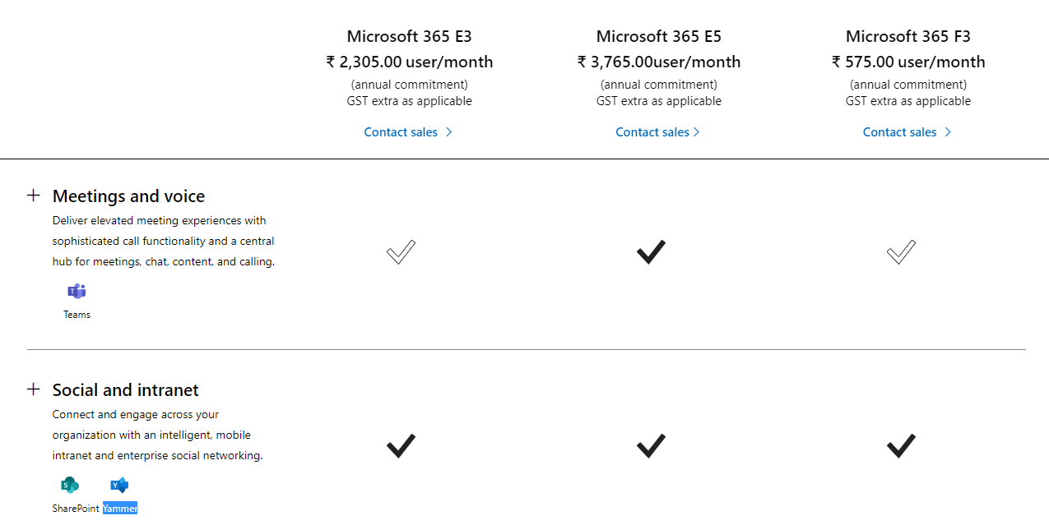

References:

**https://www.microsoft.com/en-us/microsoft-365/compare-microsoft-365-enterprise-plans**

**https://docs.microsoft.com/en-us/office365/servicedescriptions/office-365-platform-service-description/office-365-plan-options**

Bottom of Form

Top of Form

Question 14: Skipped

You use Microsoft 365 Usage Analytics.

You need to know the number of users who are active today and were also active last month.

**Which metric should you use?**

* ​

Active users

* ​

Cumulative active users

* ​

MoM returning users

**(Correct)**

* ​

Enabled users

**Explanation**

***MoM ReturningUsers***  
***Number of users active in the month that were also active in the preceding month.***

References:

**https://docs.microsoft.com/en-us/office365/admin/usage-analytics/active-user-in-usage-reports?view=o365-worldwide**

Bottom of Form

Top of Form

Question 15: Skipped

You are the Microsoft 365 administrator for a company.

***Which two admin roles***can purchase more licenses? Each correct answer presents a complete solution.

* ​

billing administrator

**(Correct)**

* ​

service administrator

* ​

global administrator

**(Correct)**

* ​

user management administrator

**Explanation**

Global administrator and Billing administrator have access

References:

**https://docs.microsoft.com/en-us/office365/admin/subscriptions-and-billing/buy-licenses?view=o365-worldwide**

Bottom of Form

Top of Form

Question 16: Skipped

You need to move videos to a Microsoft 365 tenant and ensure that the contents are automatically transcribed.

***Which Microsoft 365 service should you use?***

* ​

yammer

* ​

stream

**(Correct)**

* ​

flow

* ​

teams

**Explanation**

***Microsoft Stream is used for video services, and includes deep search within automatic audio transcription.***

References:

**https://docs.microsoft.com/en-us/stream/office-365-video-feature-breakdown**

Bottom of Form

Top of Form

Question 17: Skipped

You need to ensure that the process by which users sign in to Microsoft 365 confirms the identity of the user.

Which feature should you use?

* ​

Advanced threat protection (ATP)

* ​

Multi factor authentication (MFA)

**(Correct)**

* ​

Mobile application management (MAM)

* ​

data loss prevention (DLP) policies

**Explanation**

Multi-Factor Authentication (MFA) is a two-step identity verification system that can be used to authenticate users.

Reference:

**https://docs.microsoft.com/en-us/azure/active-directory/authentication/concept-mfa-howitworks**

Bottom of Form

Top of Form

Question 18: Skipped

You are a Microsoft 365 administrator for a company.

You need to ensure that company documents are marked as confidential. You must prevent employees from sharing documents with people outside the company.

What are ***two possible ways*** to achieve the goal? Each correct answer presents a complete solution.

* ​

validate outbound emails by using Domainkeys identified Mails (DKIM)

* ​

Apply sensitivity labels to documents

**(Correct)**

* ​

Create a data loss prevention policy

* ​

Create sensitive information types

**(Correct)**

* ​

Configure secure/multipurpose internet mail extensions (S/MIME) settings for Outlook

**Explanation**

***Sensitive information types can also be used with the Azure Information Protection scanner to classify and protect files on premises.***Sensitive information types define how the automated process recognizes specific information types such as health service numbers and credit card numbers.

***With sensitivity labels you can classify and help protect your sensitive content.***Protection options include labels, watermarks, and encryption.

Reference:

**https://docs.microsoft.com/en-us/microsoft-365/compliance/protect-information**

Bottom of Form

Top of Form

Question 19: Skipped

You are the Microsoft administrator for a company all staff must use Microsoft Outlook to access corporate email. When users access outlook on mobile devices they must use a PIN to open the application. You need to implement a Microsoft intune policy to enforce the security requirements.

Which policy should you use?

* ​

App protection

**(Correct)**

* ​

Device compliance

* ​

device configuration

* ​

App configuration

**Explanation**

**App protection policies make sure that the app-layer protections are in place.** For example, you can:

Require a PIN to open an app in a work context

Control the sharing of data between apps

Prevent the saving of company app data to a personal storage location

Reference:

**https://docs.microsoft.com/en-us/intune/app-protection-policy**

Bottom of Form

Top of Form

Question 20: Skipped

You are the Microsoft 365 administrator for a company.

You need to identify available cloud security features.

Match this feature to the correct description.

**Block users from accessing cloud apps from certain devices.**

* ​

Microsoft azure security centre

* ​

Cloud discovery dashboard

* ​

Microsoft azure Information protection

* ​

Microsoft Azure AD conditional access

**(Correct)**

**Explanation**

Reference:

**https://docs.microsoft.com/en-us/azure/active-directory/conditional-access/overview**

Bottom of Form

Top of Form

Question 21: Skipped

True/False: **"After users are enrolled in MFA they must configure a second authentication factor the next time they sign in"**

* ​

True

**(Correct)**

* ​

False

**Explanation**

This is true. Read more details below.

Reference:

**https://docs.microsoft.com/en-us/azure/active-directory/authentication/howto-mfa-userstates**

Bottom of Form

Top of Form

Question 22: Skipped

You are the Microsoft Office 365 administrator for a company.

You need to perform security and compliance reviews before new updates are distributed to the entire company.

**What should you implement?**

* ​

targeted releases

**(Correct)**

* ​

Fastrack

* ​

Microsoft 365 Enterprise test lab

* ​

standard releases

**Explanation**

With this option, ***you and your users can be the first to see the latest updates and help shape the product by providing early feedback.***You can choose to have individuals or the entire organization receive updates early.

Reference:

**https://docs.microsoft.com/en-us/office365/admin/manage/release-options-in-office-365?view=o365-worldwide**

Bottom of Form

Top of Form

Question 23: Skipped

True/False :"Once a device is registered with Microsoft Intune data wipe will include users personal data"

* ​

False

**(Correct)**

* ​

True

**Explanation**

**Policies are not applied on the app in a personal context.** They only apply in a work context, which gives one the flexibility to protect company data without compromising personal data.

Reference:

**https://docs.microsoft.com/en-us/mem/intune/fundamentals/what-is-intune**

Bottom of Form

Top of Form

Question 24: Skipped

A company has an Exchange Server environment. The company plans to migrate to the cloud. You need to recommend a cloud model that meets the following requirements:

Upgrade the existing email environment.

Minimize server and application management.

**Which model should you recommend?**

* ​

Paas

* ​

Waas

* ​

Saas

**(Correct)**

* ​

Iaas

**Explanation**

Software as a service (SaaS) allows users to connect to and use cloud-based apps over the Internet. Common examples are email, calendaring, and office tools (such as Microsoft Office 365). To minimize costs SaaS is the best option here as server management will be the responsibility of the cloud service providers. You can also reap added benefits of being current with the latest technologies in mail management.

Bottom of Form

Top of Form

Question 25: Skipped

When talking about cloud services, what does the term "scalable" mean?

* ​

resize organizational data structures

* ​

add or reduce service capacity on demand

**(Correct)**

* ​

services are deployed in a redundant manner

* ​

able to build models

**Explanation**

**Cloud scalability** in **cloud** computing refers to the ability to increase or decrease IT resources as needed to meet changing demand. **Scalability** is one of the hallmarks of the **cloud** and the primary driver of its exploding popularity with businesses.

Reference:

**https://www.vmware.com/topics/glossary/content/cloud-scalability**

Bottom of Form

Top of Form

Question 26: Skipped

True/False: **"MAM requires Intune device enrollment."**

* ​

True

* ​

False

**(Correct)**

**Explanation**

Reference:

**https://docs.microsoft.com/en-us/mem/intune/fundamentals/what-is-intune**

Bottom of Form

Top of Form

Question 27: Skipped

The default setting for the number of days in which a password expires is _____ days.

* ​

30

* ​

60

* ​

90

**(Correct)**

* ​

120

**Explanation**

***By default, passwords are set to expire in 90 days.*** Current research strongly indicates that mandated password changes do more harm than good.

Reference:

**https://docs.microsoft.com/en-us/microsoft-365/admin/manage/set-password-expiration-policy?view=o365-worldwide**

Bottom of Form

Top of Form

Question 28: Skipped

An employee is leaving your company. They have used their own device to access corporate data. You need to ensure that all corporate data is wiped from the enrolled device. What Microsoft Intune remote action would you use?

* ​

Retire

**(Correct)**

* ​

Pass code reset

* ​

Remote lock

**Explanation**

The **Retire** action removes managed app data (where applicable), settings, and email profiles that were assigned by using **Intune**. The device is removed from **Intune** management. This happens the next time the device checks in and receives the remote **Retire** action

Reference:

**https://docs.microsoft.com/en-us/mem/intune/remote-actions/devices-wipe**

Bottom of Form

Top of Form

Question 29: Skipped

You can view the past X days of Health History in the Microsoft 365 admin center. What is **X**?

* ​

7

* ​

30

**(Correct)**

* ​

60

* ​

90

**Explanation**

History

Service health lets you look at current health status and view the history of any service advisories and incidents that have affected your**tenant in the past 30 days.**

Reference:

**https://docs.microsoft.com/en-us/microsoft-365/enterprise/view-service-health?view=o365-worldwide**

Bottom of Form

Top of Form

Question 30: Skipped

You need to enable your users to create and manage projects using the Office 365 suite. Which Office 365 application is best suited to accomplish this task?

* ​

Sharepoint online

* ​

Planner

**(Correct)**

* ​

Stream

* ​

Microsoft outlook

**Explanation**

A planner can be used to create simple projects or plans and allows for participating to assign and manage tasks. The planner can be integrated into teams.

Reference:

**https://www.microsoft.com/en-in/microsoft-365/business/task-management-software**

Bottom of Form

Top of Form

Question 31: Skipped

Identify two features or capabilities of the Secure Score?

* ​

recommend security configurations for the Microsoft 365 services

**(Correct)**

* ​

administer user risk policies

* ​

provide configuration steps for security recommendations for links to configuration controls

**(Correct)**

* ​

Track user security policies

**Explanation**

Microsoft Secure Score is a measurement of an organization's security posture, with a higher number indicating more improvement actions taken.

**Secure Score helps organizations:**

Report on the current state of the organization's security posture.

Improve their security posture by providing discoverability, visibility, guidance, and control.

Compare with benchmarks and establish key performance indicators (KPIs).

**Reference:**

**https://docs.microsoft.com/en-us/microsoft-365/security/mtp/microsoft-secure-score?view=o365-worldwide**

Bottom of Form

Top of Form

Question 32: Skipped

When opening a service ticket, ***which severity level***is used to indicate a significant loss or degradation of services, requiring immediate attention?

* ​

A

**(Correct)**

* ​

B

* ​

C

* ​

D

**Explanation**

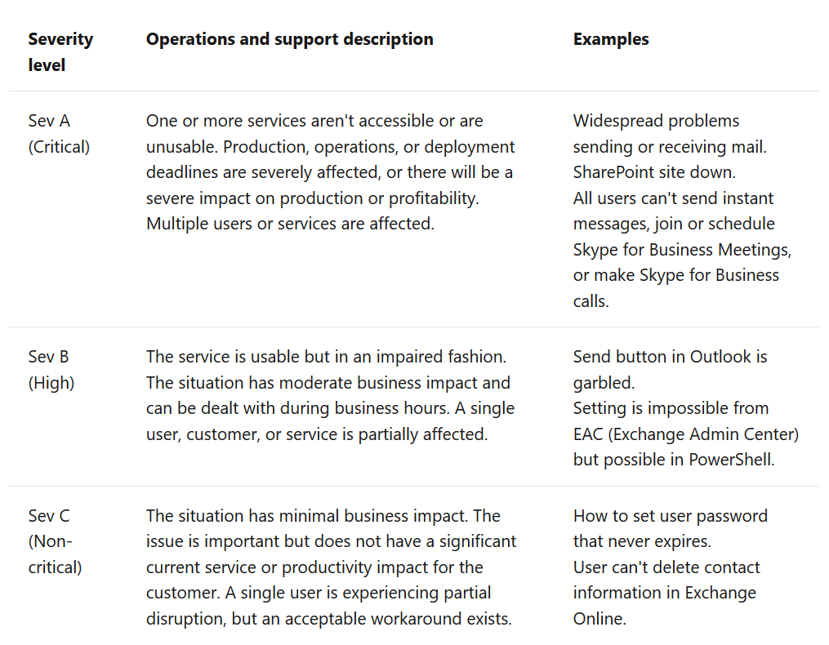

Reference:

**https://docs.microsoft.com/en-us/office365/servicedescriptions/office-365-platform-service-description/support**

Bottom of Form

Top of Form

Question 33: Skipped

How can a PowerApps application be added to Microsoft Teams channel?

* ​

By creating a webhook

* ​

By creating a tab

**(Correct)**

* ​

By creating a bot

**Explanation**

These apps can be added directly to Teams by creating tabs for those apps. Apps can be accessed from the tabs

Reference:

**https://docs.microsoft.com/en-us/learn/modules/engage-employees-with-microsoft-stream-teams-yammer/6-extend-teams-power-platform-apps**

Bottom of Form

Top of Form

Question 34: Skipped

Where are Microsoft Teams Meeting rooms added when creating a new Teams meeting?

* ​

The rooms will be available in the Room dropdown in the new meeting form.

* ​

The rooms won't be available in the new meeting form in Microsoft Teams.

* ​

The rooms will be available in the Location dropdown in the new meeting form.

**(Correct)**

**Explanation**

This allows participants to know which **physical meeting room (location)** to go to for the meeting.

Reference:

**https://docs.microsoft.com/en-us/learn/modules/engage-employees-with-microsoft-stream-teams-yammer/3-online-meetings-teams**

Bottom of Form

Top of Form

Question 35: Skipped

Which report contains the number of users accessing Yammer from a mobile phone?

* ​

Yammer activity reports.

* ​

Yammer group activity reports.

* ​

Yammer device usage reports.

**(Correct)**

**Explanation**

These reports provide information about devices types, the number of devices, operating system type, and more across the organization, or on an individual user level.

Reference:

**https://docs.microsoft.com/en-us/learn/modules/engage-employees-with-microsoft-stream-teams-yammer/4-connect-yammer**

Bottom of Form

Top of Form

Question 36: Skipped

Which extensibility feature of Microsoft Teams allows for applications like GitHub to be integrated into a Teams channel?

* ​

Message extensions.

* ​

Bots.

* ​

Connectors.

**(Correct)**

**Explanation**

Use connectors for third-party apps like GitHub, Bitbucket, Salesforce, and more

Reference:

**https://docs.microsoft.com/en-us/learn/modules/engage-employees-with-microsoft-stream-teams-yammer/6-extend-teams-power-platform-apps**

Bottom of Form

Top of Form

Question 37: Skipped

Which of the following roles are needed to access Microsoft Stream audit logs?

* ​

An Azure Global Admin role.

* ​

A Microsoft 365 Global Admin role.

**(Correct)**

* ​

A Microsoft Yammer admin role.

**Explanation**

Microsoft Stream's audit logs can be found in Microsoft 365 audit logs. To access logs, your organization must have:

Either the Microsoft 365 Global Admin or Exchange admin role.

A valid Exchange Online license.

A valid Exchange mailbox license.

Reference:

**https://docs.microsoft.com/en-us/learn/modules/engage-employees-with-microsoft-stream-teams-yammer/5-use-stream-engagement**

Bottom of Form

Top of Form

Question 38: Skipped

Which of these is the correct list of SharePoint built-in workflows?

* ​

Approval, Collect Feedback, Collect Signatures, Publishing Approval, Three-state

**(Correct)**

* ​

Approval, Collect Feedback, Collect Signatures, Publishing Approval, Triple-state

* ​

Approval, Collect Feedback, Collect Signatures, Publishing Approval, Tri-state

**Explanation**

***SharePoint provides all these workflows to accelerate getting started with workflows***

Here is an example of a typical workflow:

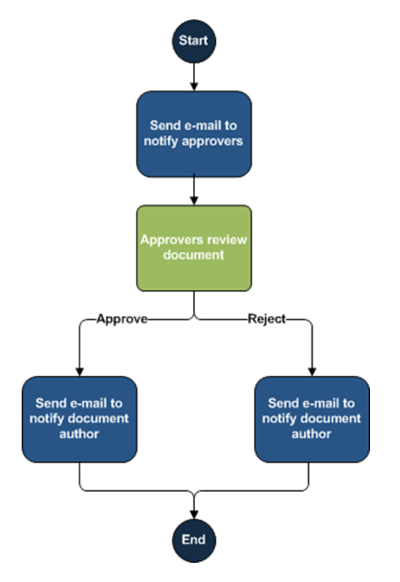

Reference:

**https://docs.microsoft.com/en-us/learn/modules/manage-your-business-with-microsoft-365/4-business-process-automation**

Bottom of Form

Top of Form

Question 39: Skipped

What two options are available to developers wanting to incorporate or use Microsoft Graph in their applications?

* ​

Microsoft Graph SOAP API, Microsoft Graph Native SDKs

* ​

Microsoft Graph REST API, Microsoft Graph Native SDKs

**(Correct)**

* ​

Microsoft Graph REST API, Microsoft Graph Windows 10 SDKs

**Explanation**

"**Microsoft Graph**

Microsoft Graph provides a unified programmability model that you can use to build apps for organizations and consumers that interact with your organization's data.To support as many developers and platforms as possible, Microsoft Graph has two options for developers to choose from when integrating Microsoft Graph into their applications.

**Microsoft Graph REST API**

At its core, Microsoft Graph is a REST API. That means that developers can use any platform, any framework, and any programming language they're most comfortable using.

**Microsoft Graph Native SDKs**

**Microsoft Graph also provid**es multiple native SDKs for developers who want to use a rich programming model within their applications. These SDKs abstract away the tasks of constructing, submitting, and processing the REST requests and responses with the Microsoft Graph REST API. You'll find an existing SDK for the platform and language you are working on as all the popular platforms covered, including .NET, iOS, Android, Java, PHP, Ruby, JavaScript, and many more."

Reference:

**https://docs.microsoft.com/en-us/learn/modules/manage-your-business-with-microsoft-365/5-extensibility**

Bottom of Form

Top of Form

Question 40: Skipped

What is the minimum Power BI license type required for your users if they only need to Consume content share with them?

* ​

Power BI Pro

* ​

Power BI

**(Correct)**

* ​

Power BI Consumer

**Explanation**

Reference:

**https://docs.microsoft.com/en-us/learn/modules/manage-your-business-with-microsoft-365/7-business-intelligence**

A user with the Power BI (Free) license type, can access content My Workspace that has been shared with them

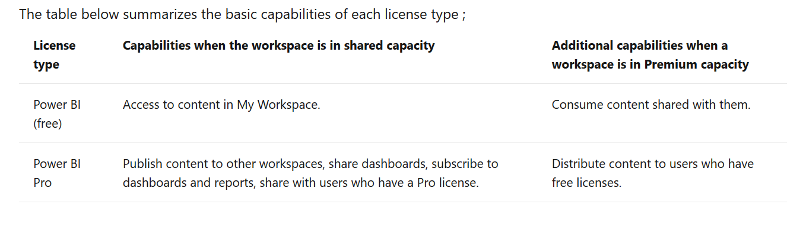

Bottom of Form

Top of Form

Question 41: Skipped

Which group of users might benefit from Windows Virtual Desktop?

* ​

Users who need to run a Mac desktop

* ​

Users who work with confidential data

**(Correct)**

* ​

Users with poor internet connectivity

**Explanation**

Windows Virtual Desktop can be configured to ensure that data is never stored on the local device.

Windows Virtual Desktop is a service that allows users to connect to a Windows desktop running in the cloud. They enjoy all the benefits of Windows desktop and Microsoft 365 apps, without the overhead of installing software on the local device.

For some situations, this gives the organizations significant benefits:

**Deploy** Windows desktops and apps in minutes.

**Scale** easily by provisioning access to data across devices fast.

Provide access to data whist adhering to **security and compliance regulations**.

Reference:

**https://docs.microsoft.com/en-us/learn/modules/get-done-stay-secure-with-windows-10/6-windows-virtual-desktop**

Bottom of Form

Top of Form

Question 42: Skipped

What would you use to manage Windows-as-a-Service?

* ​

Configuration Manager

**(Correct)**

* ​

Windows updates

* ​

Windows Virtual Desktop

**Explanation**

Windows Virtual Desktop allows one to run Windows 10 in the cloud but not Windows-as-a-Service.

Windows updates are used to distribute security updates.

**Configuration Manager allows one to configure Windows-as-a-Service including Service Channels and Deployment rings.**

Reference:

**https://docs.microsoft.com/en-us/learn/modules/get-done-stay-secure-with-windows-10/2-windows-service**

Bottom of Form